**SOFTWARE ENGINEERING**

**(IT-314)**

**EVENT PLANNER APPLICATION**

User Manual

Version 1.0

**Team no: 14**

**Instructor: Prof. Asim Banerjee**

**Team Mentor: K Hemantha**

**Date: 5 April, 2016**

**Team Members**

|  |  |  |
| --- | --- | --- |
| **S.No** | **Name** | **ID** |
| 1. | Patel Yash | 201301008 |
| 2. | Patel Tej Naginbhai | 201301018 |
| 3. | Anavadiya Yash Kumar | 201301052 |
| 4. | Chauhan Dwimitra Dharmendra | 201301079 |
| 5. | Rahul Shashank Saranjame (Team Leader) | 201301101 |
| 6. | Fatnani Varun Kumarbhai | 201301152 |
| 7. | Nikita Jain | 201301155 |
| 8. | Karri Kiran Satish Reddy | 201301168 |
| 9. | Raman Kumar Douchaniya | 201301202 |

**Version History**

|  |  |  |
| --- | --- | --- |
| **Date** | **Version no.** | **Authors** |
| 5/04/2016 | 1.0 | Rahul Saranjame |

**Table of Contents**

1. Introduction....................................................................................................4

1.1 Purpose ............................................................................................4

1.2 Scope ……………...........................................................................4

1.3 Authorised User Permissions...........................................................4

2. Product Description........................................................................................5

2.1 Product Perspective..........................................................................5

2.2 Product Functions.............................................................................5

2.3 User Classes………..........................................................................5

3. System Specification.......................................................................................5

3.1 Operating Environment …………………………………………....5

3.2 System Features ……………………………………………………6

3.3 Performance Requirements ………………………………………..6

4. Application Walkthrough ................................................................................7

4.1 Home Screen ………………………………………………………7

4.2 View Upcoming Events …………………………………………... 7

4.3 Login View ………………………………………………………..8

4.4 Create new event …………………………………………………10

4.5 Search View ……………………………………………………....11

4.6 Event Details ……………………………………………………...12

4.7 Email Notification …………………………………………….…..14

5. Frequently Asked Questions..……………......................................................15

6. References…………………………………………………………………...16

1. **Introduction**
   1. **Purpose**

This document aims at providing the users with a walkthrough of the Event Management webapp in an organised manner.

This document has been drafted for the client organisation All About Ads and is intended for easy and smooth use by the employees. It will also provide the organisation a quick way of clearing any queries that they might have regarding the use of the product.

The document has been composed in an easy to understand language that will grant ease to the task of understanding the application.

* 1. **Scope**

The user manual contains all the information required for the employees of the client organisation to work with the application easily. This document contains a detailed description of all the functionalities of the product and step-by-step procedures for efficient use.

* 1. **Authorized User Permissions**

Usage of this software is limited only to the client organisation All About Ads and Team 14, IT314 Software Engineering Winter 2015-2016 DA-IICT.

1. **Product Description**
   1. **Product Perspective**

The product has been designed keeping in mind the requirements of the client. The current problems of the client will be minimised to a great extent with the help of this application. The features of the application have been appropriately designed to fulfill all the client requirements,

* 1. **Product Functions**

The application will provide the user with options to create a new event entry and view the previously stored events. All the information regarding the event can be found at one place so that time and other resources are not wasted searching for them. To facilitate event detail viewing the search functionality has been implemented. Apart from this the product will also create a costing sheet on the basis of all the items added while creating/editing the event. To ensure that the event details are not privy to anyone outside the organisation each user is required to login before doing any of the above. Also the customer for whom the event is being conducted can be notified about the changes made in the event details to ensure that regular communication is maintained,

* 1. **User Classes**

The users of this application will be the employees of the client organisation All About Ads. There are only two types of privileges:

* Admin: The main head who has all the rights that the general user has but can additionally delete the event.
* General User: The general user can access all the product functionalities like viewing, creating and editing new events. He is barred from deleting an event.

1. **System Specifications**
   1. **Operating Environment**

The web application has been designed on Wordpress platform. For database creation we have used mysql database and HTML,CSS,BOOTSTRAP have been used for web development and front end coding. For Back end coding we are using sql,php,ajax Execution of queries has been carried out with the help of XAMPP.

* 1. **System Features**
* **Registration Feature:** The user is required to register with a User ID given to him by the organisation and a unique password. He is also required to provide contact information like his phone number and email address for password recovery.
* **Login Feature:** The user can login with the registered User ID and his password and can also recover password in case of loss.
* **Create Event:** The user can start planning a new event by adding appropriate information like the client details and event time and date. He is then directed to a page for adding different event elements and choose appropriate vendors.
* **Search Event:** The user can search for any past event through a variety of ways. He can use Location Search, Vendor Search etc. depending on what he wishes to.
* **Costing Sheet Generation:** According to the vendors and items involved in each event, the system will generate a costing sheet which will have the cost breakdown for the concerned event.
* **Event Details:** All event details about any past event will be stored in the system for quick reference by the user. These will include everything from the pitching details to the photographs and videos for the event. These can be accessed by using the search feature to search for the appropriate event.
* **Notifying the Customer:** In case the user has made monumental changes to the event and wishes to notify the customer, he can do so while saving the details. This will send an email notification to the customer so that he can have a look.
* **Deleting an Event:** This feature is only available to the heads of the organisation and not all users. This has been done so as to avoid accidental deletion of any event that might be deemed worth deleting but is not.
  1. **Performance Requirements**
* The users will have a unique User ID and password for login.
* The delete event feature has been given exclusive user privileges to make sure that no event is accidentally deleted without proper consideration.
* The database will be backed up to avoid data loss
* The user will also be provided with an option to change password to provide security to the details.

1. **Application Walkthrough**
   1. **Home Screen**

The home screen looks as follows

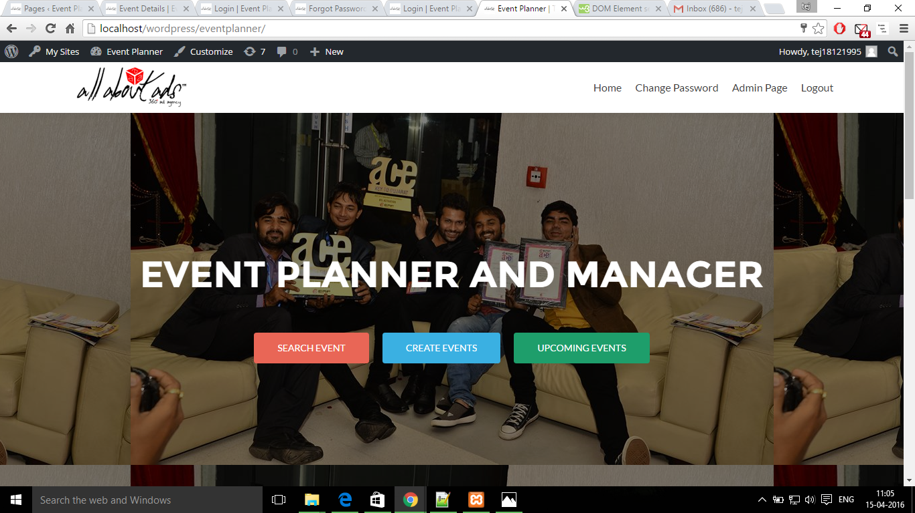

The user has options of searching for an event, creating new events and viewing upcoming events.

* 1. **View upcoming Events**

Upcoming events can be viewed here

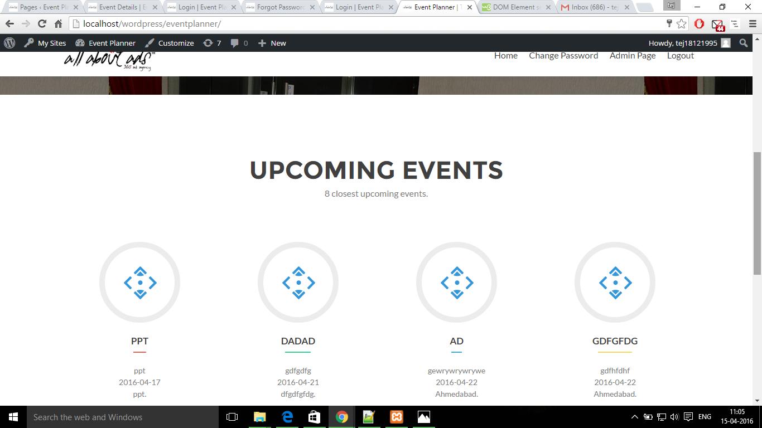

* 1. **Login View**

Each user is prompted with a login window before they can access any of the system functionalities.

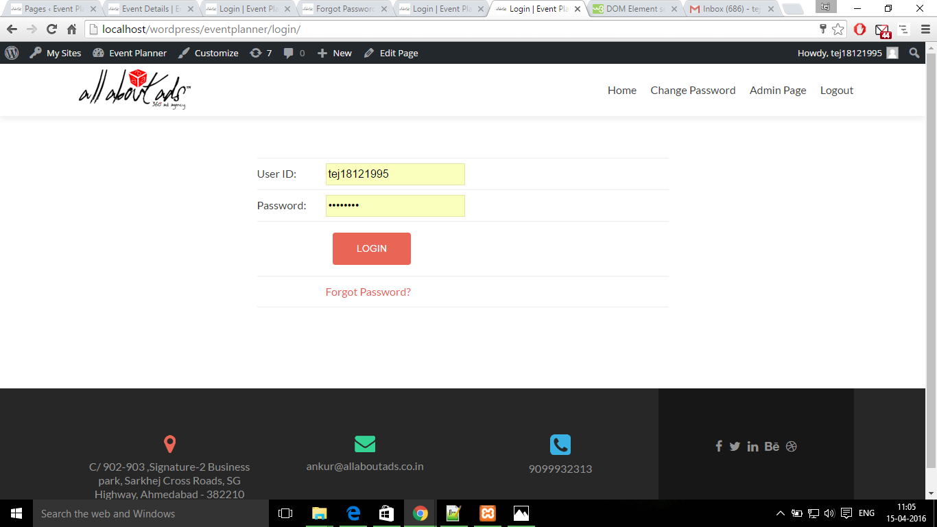

In case the user enters an incorrect password, the following window appears

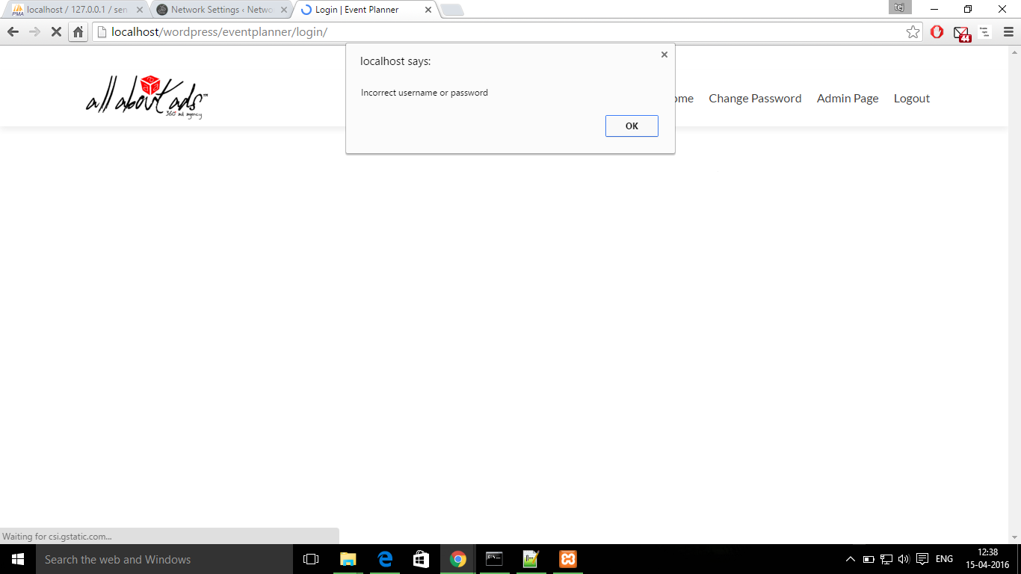

If the user clicks the forgot password button, the user is required to enter the User ID or email address submitted at the time of registration to facilitate password recovery.

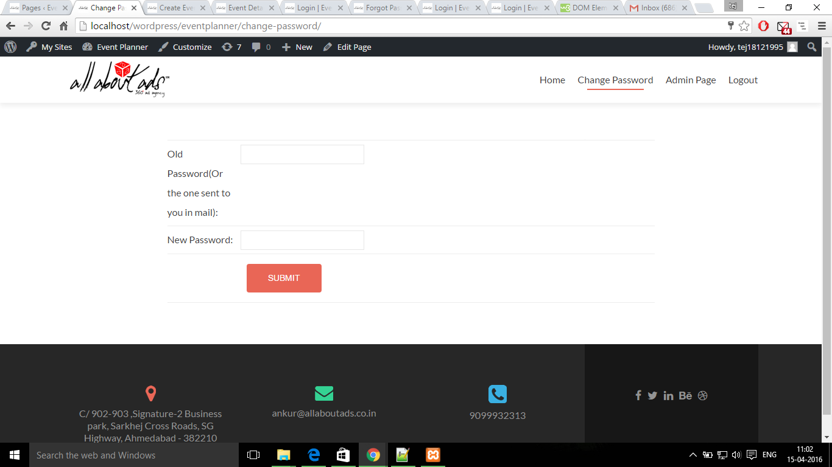

Suppose the user is a new user and wishes to register, he is redirected to a new page where the details are to be filled in.

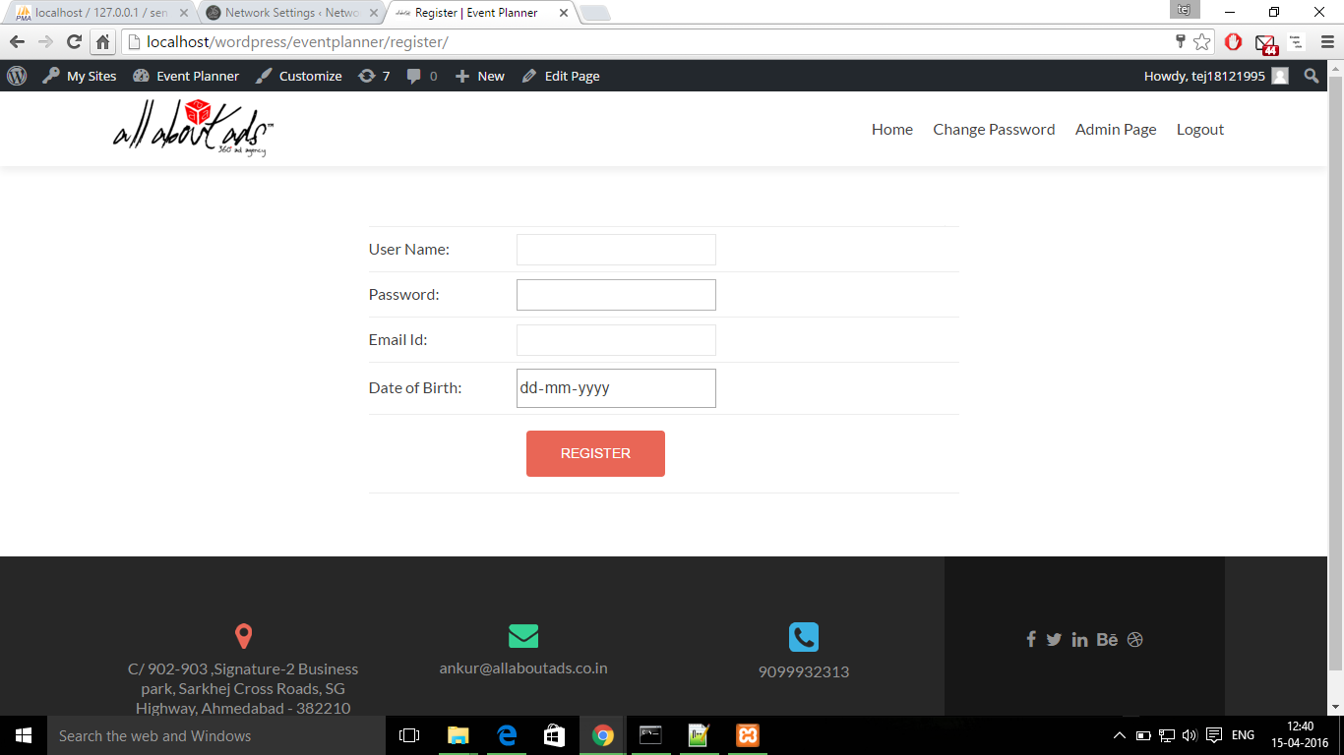

* 1. **Create New Event**

The user can start planning a new event by adding the required details about the items required and entering the required details. Once the event is saved, it can be searched for using the search option.

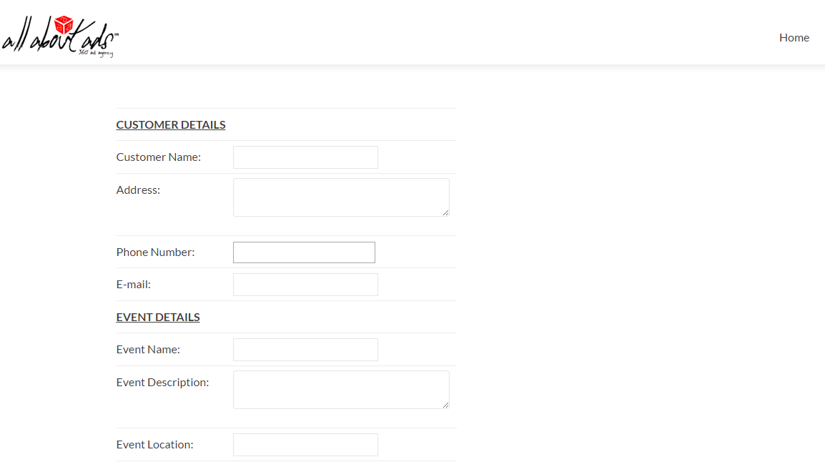

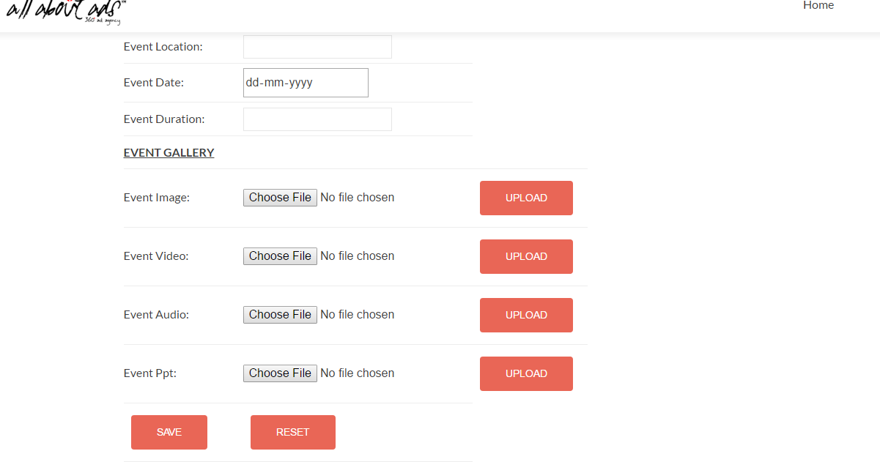

* 1. **Search View**

The user is prompted with the following window for searching for an event

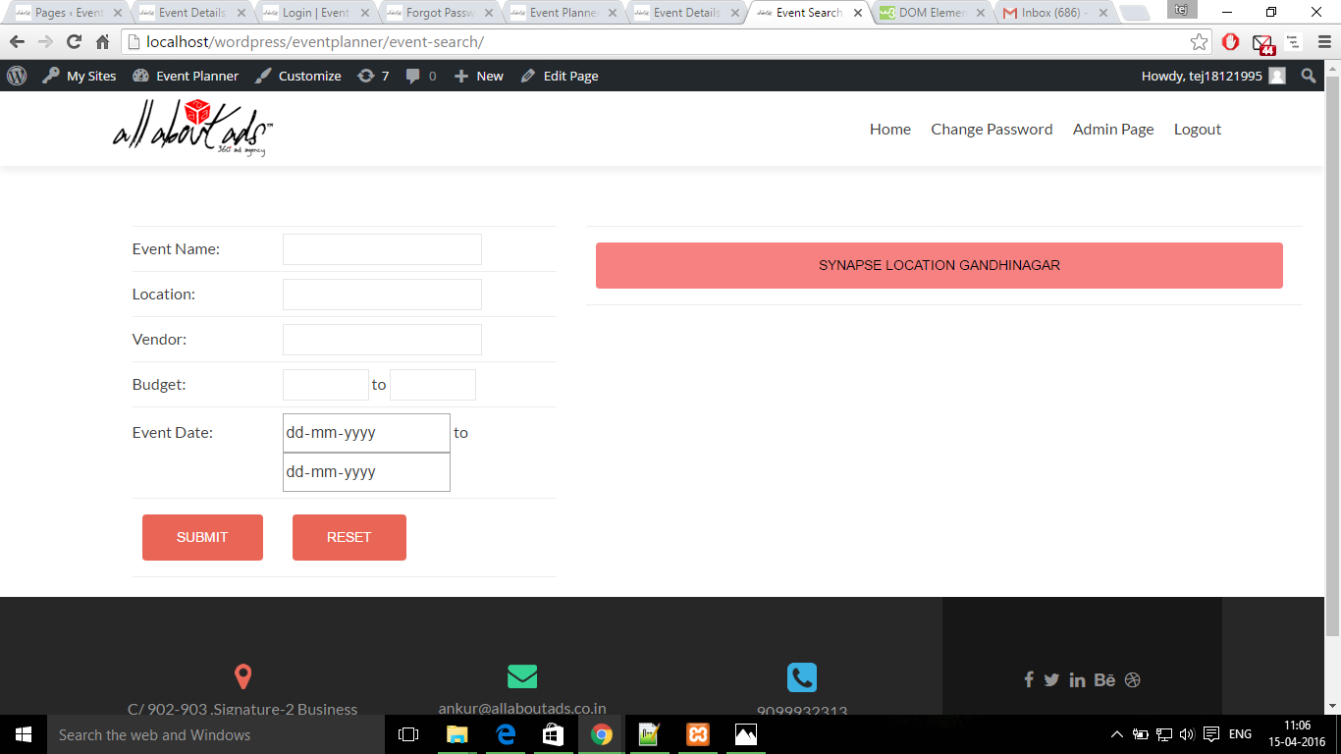

* 1. **Event Details**

The search will lead to results that can be used by the user to view and edit event details.

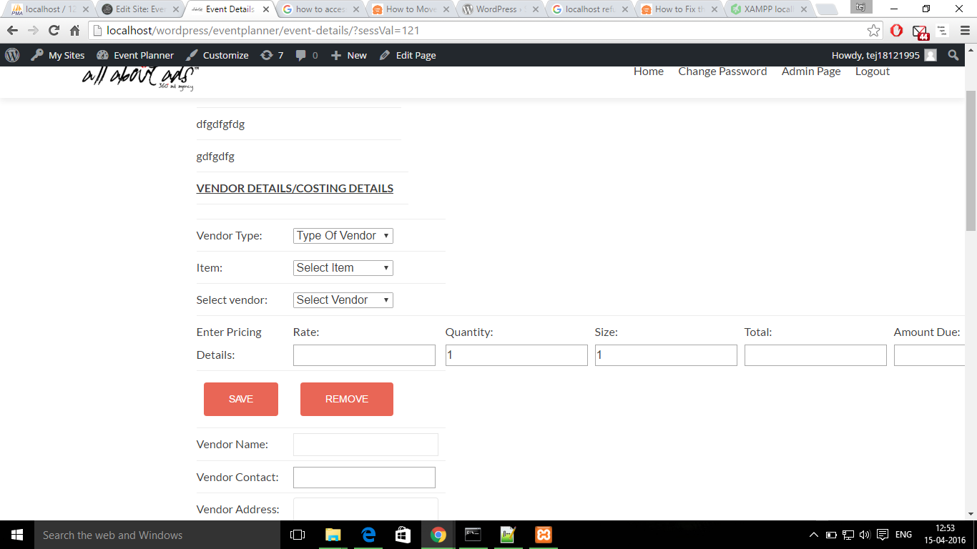

In the above window, the user can add and remove vendors according to the items required and edit the minute details.

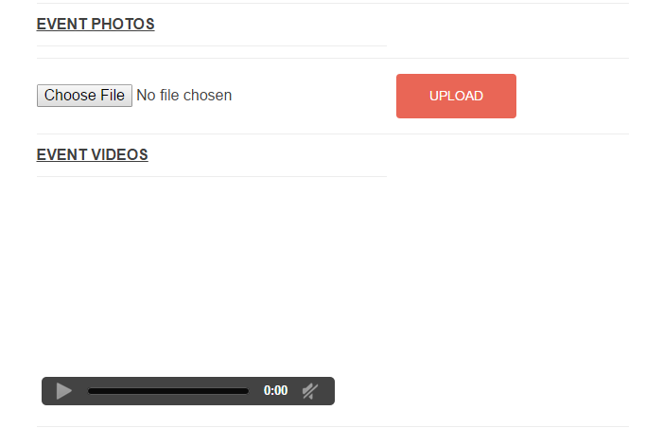

Here the user can view and upload the various media elements involved with the event like photos and videos.

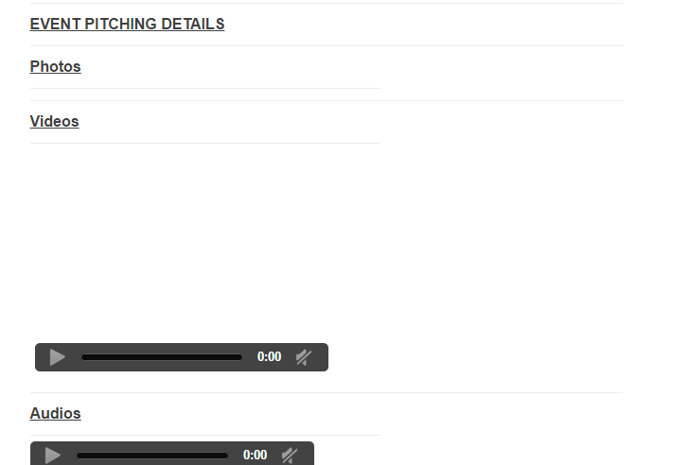

The user can also view and edit all the details and documents uploaded during the pitching stage of the event.

* 1. **Email Notification**

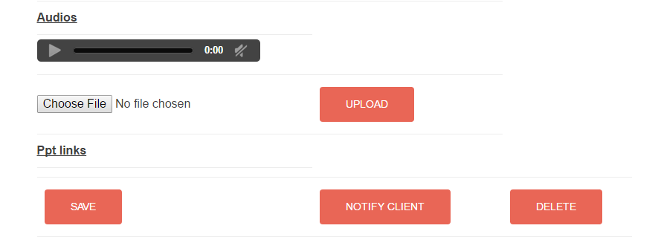

In case the user makes major changes to the event details and wishes to notify their client (the customer for whom the event is conducted) seeking approval, he has the option to send an email notification to the customer.

1. **Frequently Asked Questions (FAQ)**
2. How to create an event ?

* Open Chrome -> Enter the url:- localhost//wordpress/eventplanner/
* Login with your credentials.
* Click on the Create Events button located at the centre of the Homepage. You will be redirected to Create Event page
* Fill the required fields and click on Save to successfully create your event

.

1. How to upload images, videos or presentations ?

* Open Chrome -> Enter the url:- localhost//wordpress/eventplanner/
* Login with your credentials.
* Click on the Search Event button located at the centre left of the Homepage. You will be redirected to the Event Search page.
* Fill at least one of the fields and press Submit button. Events matching that criterion will be displayed. Click on the event.
* You will be redirected to Event Details page. Click on the Choose File and click Upload.

1. How to change password ?

* Open Chrome -> Enter the url:- localhost//wordpress/eventplanner/
* Login with your credentials.
* Click on the Change Password option available at the top right corner of the Homepage. You will be redirected to Change Password page.
* Enter your old password and new password and click on Submit. You will be redirected to the Homepage.

1. How to search for an event ?

* Open Chrome -> Enter the url:- localhost//wordpress/eventplanner/
* Login with your credentials.
* Click on the Search Event button located at the centre left of the Homepage. You will be redirected to the Event Search page.
* Fill at least one of the fields and press Submit button. Events matching that criterion will be displayed. Click on the event.

1. How to add a Vendor to an Event ?

* Open Chrome -> Enter the url:- localhost//wordpress/eventplanner/
* Login with your credentials.
* Click on the Search Event button located at the centre left of the Homepage. You will be redirected to the Event Search page.
* Fill at least one of the fields and press Submit button. Events matching that criterion will be displayed. Click on the event.
* There will be two options : Add from existing vendor and Add new vendor. Choose accordingly and fill the vendor details and click on Save.

1. What procedure to follow if I forget my password?

* Open Chrome -> Enter the url:- localhost//wordpress/eventplanner/
* Click on the “Forgot Password?” link. You will be redirected to the Forgot Password page.
* Enter your user-id or E-mail address. A mail will be sent to the email address you are registered with which will contain a new one-time password.
* Login with that one-time password.
* Click on the Change Password option available at the top right corner of the Homepage. You will be redirected to Change Password page.
* Enter the one-time password and new password and click on Submit. You will be redirected to the Homepage.

1. **References**

* Team 7, User Manual, IT314 Software Engineering, Winter 2012-2013
* Team 14, Software Requirements Specification, IT314 Software Engineering, Winter 2015-2016